**User Guide**

**Commerce Bank System**

04/26/2020

**Team Members**

Michelle Frost

Debbie Kirchner

Brian Roden

Linden Stirk

Issac Zeilinger

Document Control

**Change History**

|  |  |  |  |
| --- | --- | --- | --- |
| **Revision** | **Change Date** | **Change By** | **Description of changes** |
| V1.0 | 04/20/2020 | Issac Zeilinger | Initial release |
| V1.1 | 04/23/2020 | Issac Zeilinger | Transaction & homepage section |
| V1.2 | 04/24/2020 | Linden Stirk | Formatting changes |
| V1.3 | 04/24/2020 | Debbie Kirchner | Login page section |
| V1.4 | 04/25/2020 | Issac Zeilinger | Formatting, Getting Started & Table of Contents; Notifications |
| V1.5 | 04/26/2020 | Linden Stirk | Final release |

**Table of Contents**

**1 GETTING STARTED 4**

1.1 Introduction 4

1.2 Troubleshooting FAQ 4

**2 COMMON USE CASES 4**

2.2 Resetting a Password 4

2.2 Entering a Deposit 4

2.3 Checking for an Overdraw Notification 4

**3 LOGIN SCREEN 5**

3.1 Sign In 5

3.2 Sign Up 6

**4 USING THE HOME SCREEN**  **7**  
  
**5** **TRANSACTIONS** **8**

5.1 Viewing Transaction History 8

5.2 Adding Transactions 8

**6 NOTIFICATIONS 9**

6.1 Notification Tab 9

# **Getting Started**

## ***1.1 Introduction***

The Commerce Bank System web application allows customers who bank with Commerce an easy way to access their accounts online. This guide will walk through how to access the home page, transaction history, the ability to create and apply notification triggers specific to a customer’s preference, and the ability for customers to export transactions in a spreadsheet.

## ***1.2 Troubleshooting FAQ***

* The Commerce Bank System uses Firebase to log in and authenticate users who choose to sign in with Google. If you are authenticating with Google, make sure pop-ups are enabled.
* If you have forgotten your user information, you may request a new password to be sent to your email with the *Forgot Password* link

## **Common Use Cases**

## ***2.1 Resetting a Password***

On the login page, simply click on the *Forgot Password* link. A link to reset your password will be to be sent to your email.

## ***2.2 Entering a Deposit***

1. Login to your account.
2. Click on the *Add Transaction* button.
3. Enter the account number, transaction type, amount, and description of the transaction.

## ***2.3 Checking for an Overdrawn Notification***

1. Login to your account.
2. Click on the *Notification* button.
3. Sort notifications by date.

# **Login Screen**

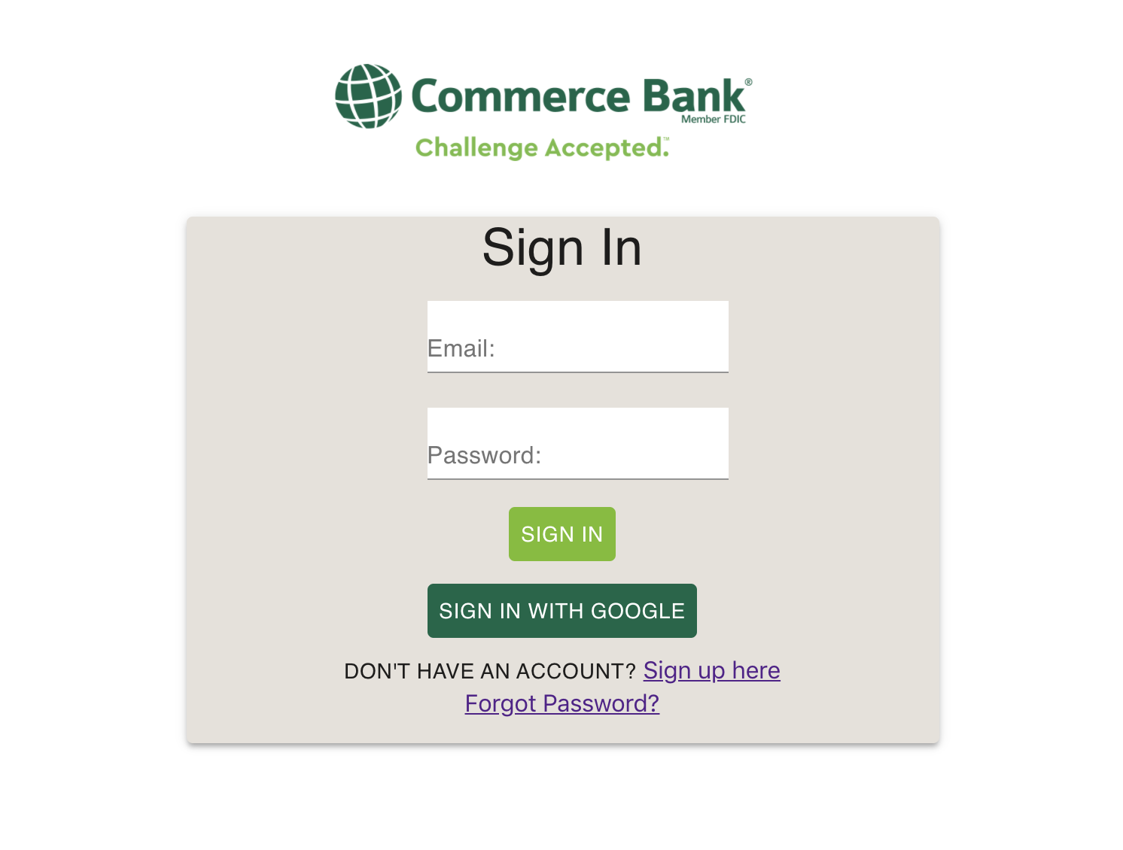

Example 1

## ***3.1 Sign In***

Users have two methods of signing in. Any Google account may be used for authentication, in which case the only required steps will be to click *Sign in with Google* using the popup in Example 2. Users who do not wish to link accounts may instead use a Commerce Bank System account. Users with existing accounts enter their email address for the account into the first text box, and their password in the second, as shown in Example 3. After clicking the *Sign In* button, users will be directed to the home screen if their login credentials are valid. If the user does not have an account, they may click on the *Sign up here* link, which will direct them to the *Sign Up* screen in Example 3.

## 

Example 2

## ***3.2 Sign Up***

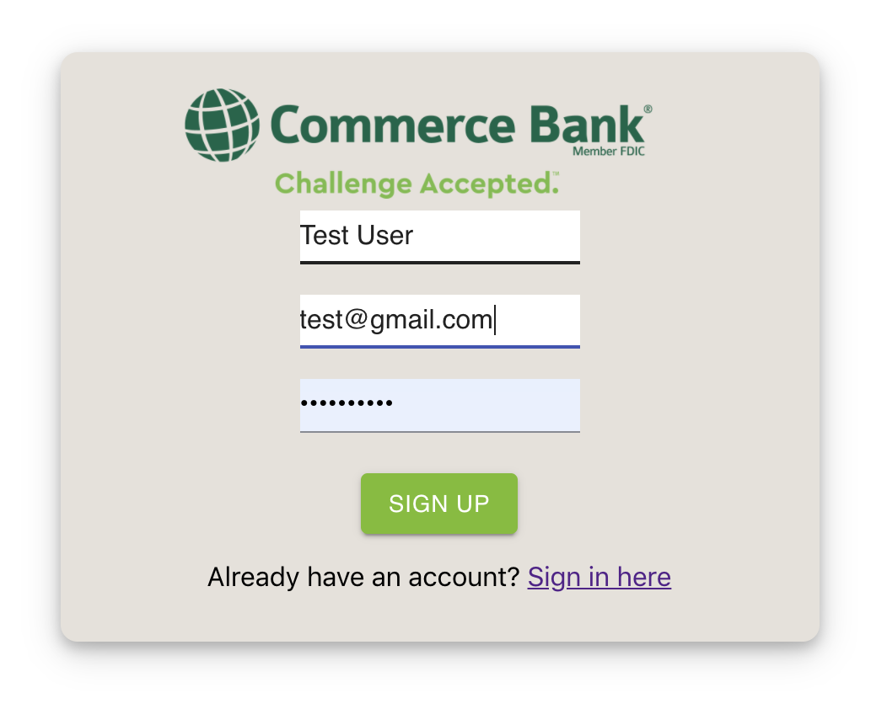

Example 3

Users making new accounts will enter their name into the first text box, a valid email address into the second, and a password into the third (shown in Example 3). After clicking the *Sign Up* button, they are directed to the home screen if the information entered is authenticated. If the user already has an account and does not need to sign up, they may click the *Sign in here* link, which will direct them to the *Sign In* screen.

# **Using the Home Screen**

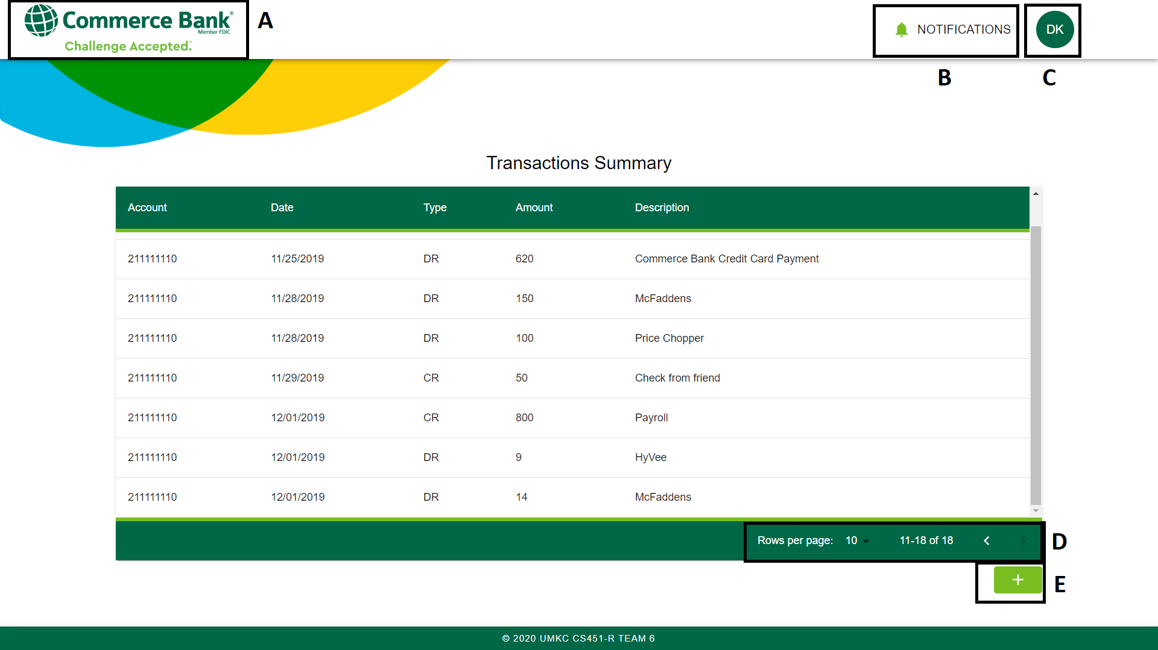

Example 4

The homepage will default to showing all transactions for the current user sorted by date. Users may return to this view at any time by clicking the top left icon marked under example 4-A. The *Notification* subpage may be opened using 4-B, and the *Transaction* subpage with 4-E. A user may log out by clicking the user profile icon at 4-C and selecting the *Logout* button.

# **Transactions**

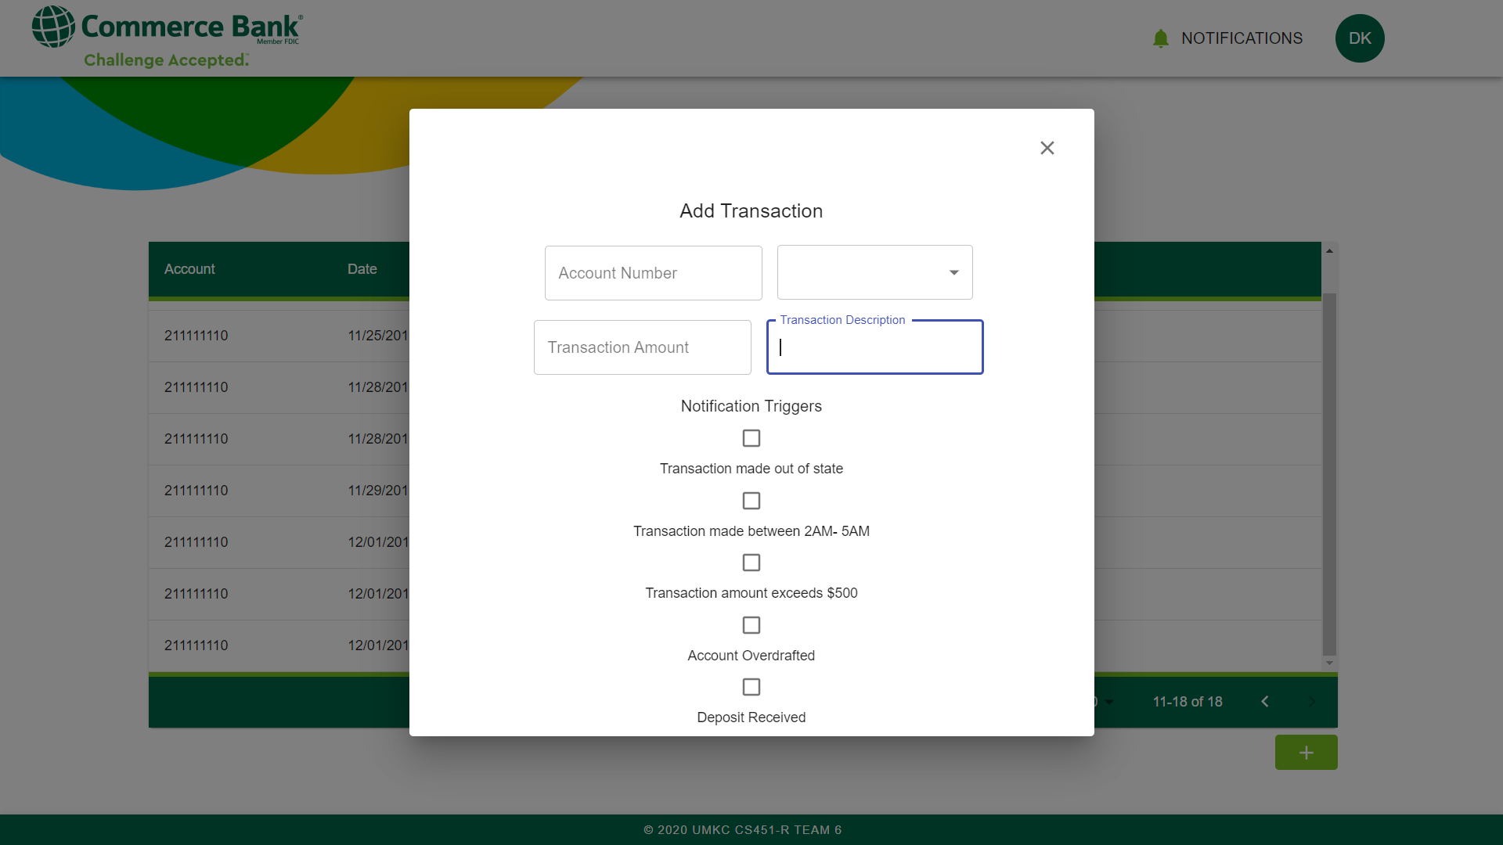

Example 5

## ***5.1 Viewing Transaction History***

The homepage is centered around viewing transaction history. The rows per page and the current subpage may be adjusted with the navigation menu bar marked at 4-D.

## ***5.2 Adding Transactions***

The button marked at 4-E will open a Transaction subpage, shown in Example 5. Required fields are an account number, transaction type, amount, and a description of the transaction.

# **Notifications**

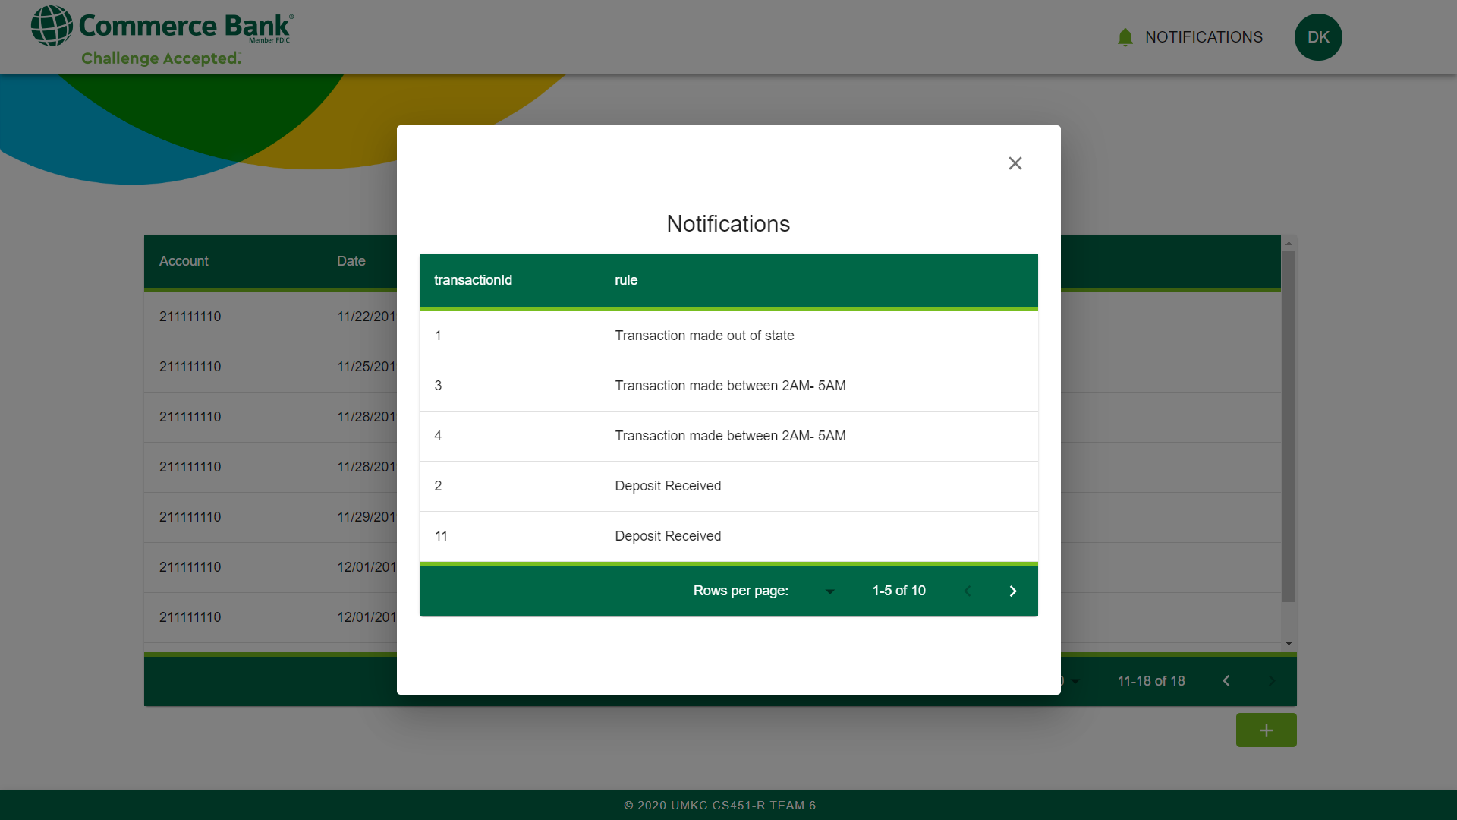

Example 6

## ***6.1 Notification Tab***

The *Notification* tab at 4-B will open the *Notification* subpage. Receiving a new notification will change the color of the bell icon to inform users of changes. Opening the tab will dismiss the notification, resetting the bell icon to grey. If applicable, the ID of the transaction that triggered the notification will be shown. Clicking the ID will go to the corresponding transaction.